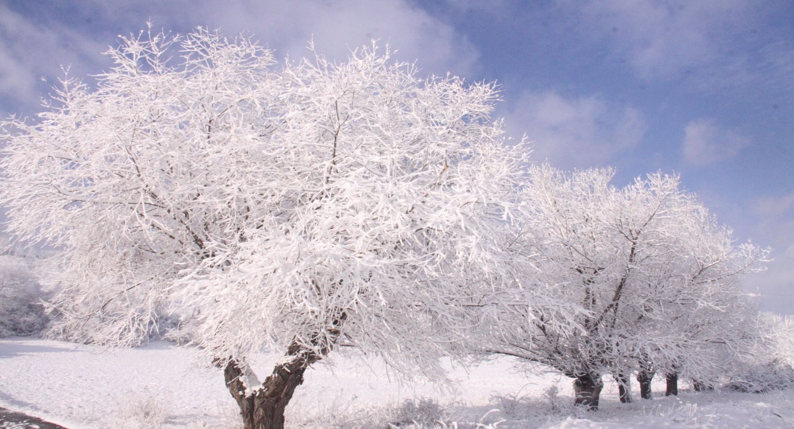

[This Photo](https://commons.wikimedia.org/wiki/File:Winter_Season.JPG) by Unknown Author is licensed under [CC BY-SA](https://creativecommons.org/licenses/by-sa/3.0/)

Sky Dogs

January

Schedule of Classes

|  |
| --- |
| **Sunday – No Classes** |
| **Monday – Classes begin 1/6/25**   * 6pm-7pm: Agility Level 3 * 7pm-8pm: Agility Level 2 * 8pm-9pm: Agility Level 1 |
| **Tuesday – Classes begin 1/7/25**   * 6pm-7pm: Agility Level 5 * 7pm-8pm: Agility Level 3 * 8pm-9pm: Agility Level 4 |
| **Wednesday – Classes begin 1/8/25**   * 6pm-7pm: Competition Obedience * 7pm-8pm: Agility Level 4 * 8pm-9pm: Agility Level 1 |
| **Thursday – Classes begin 1/9/25**   * 6:45pm-7:45pm: Perfecting Handling Techniques (competing in CPE level 3 and up) * 8pm-9pm: Advanced/Competition Agility Skills (competing in CPE level 5 and up) |
| **Saturday – Classes begin 1/4/25**   * 1pm-2pm: Agility Level 4 * 2pm-3pm: Agility Level 5 * 3pm-4pm: Agility Level 2 |