Sky Dogs
March 2025
Schedule of Classes
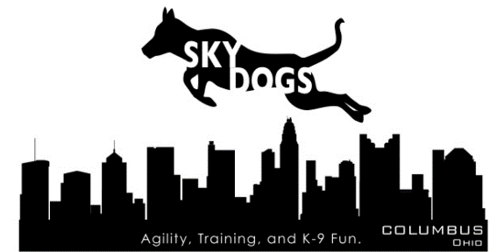
Sunday – No Classes
Monday – Classes begin 3/10/2025
- 6pm-7pm: Agility Level 3
- 7pm-8pm: Agility Level 2
- 8pm-9pm: Agility Level 1

Tuesday – Classes begin 3/11/2025
- 6pm-7pm: Agility Level 5
- 7pm-8pm: Agility Level 3
- 8pm-9pm: Agility Level 4

Wednesday – Classes begin 3/12/2025
- 6pm-7pm: Competition Obedience
- 7pm-8pm: Agility Level 4
- 8pm-9pm: Tricks

Thursday – Classes begin 3/6/2025
- 6:45pm-7:45pm: Perfecting Handling Techniques (competing in CPE level 3 and up)
- 8pm-9pm: Advanced/Competition Agility Skills (competing in CPE level 5 and up)

Saturday – Classes begin 3/8/2025
- 1pm-2pm: Agility Level 4
- 2pm-3pm: Agility Level 5
- 3pm-4pm: Weaves

